ChatBoX40

Operator’s Manual

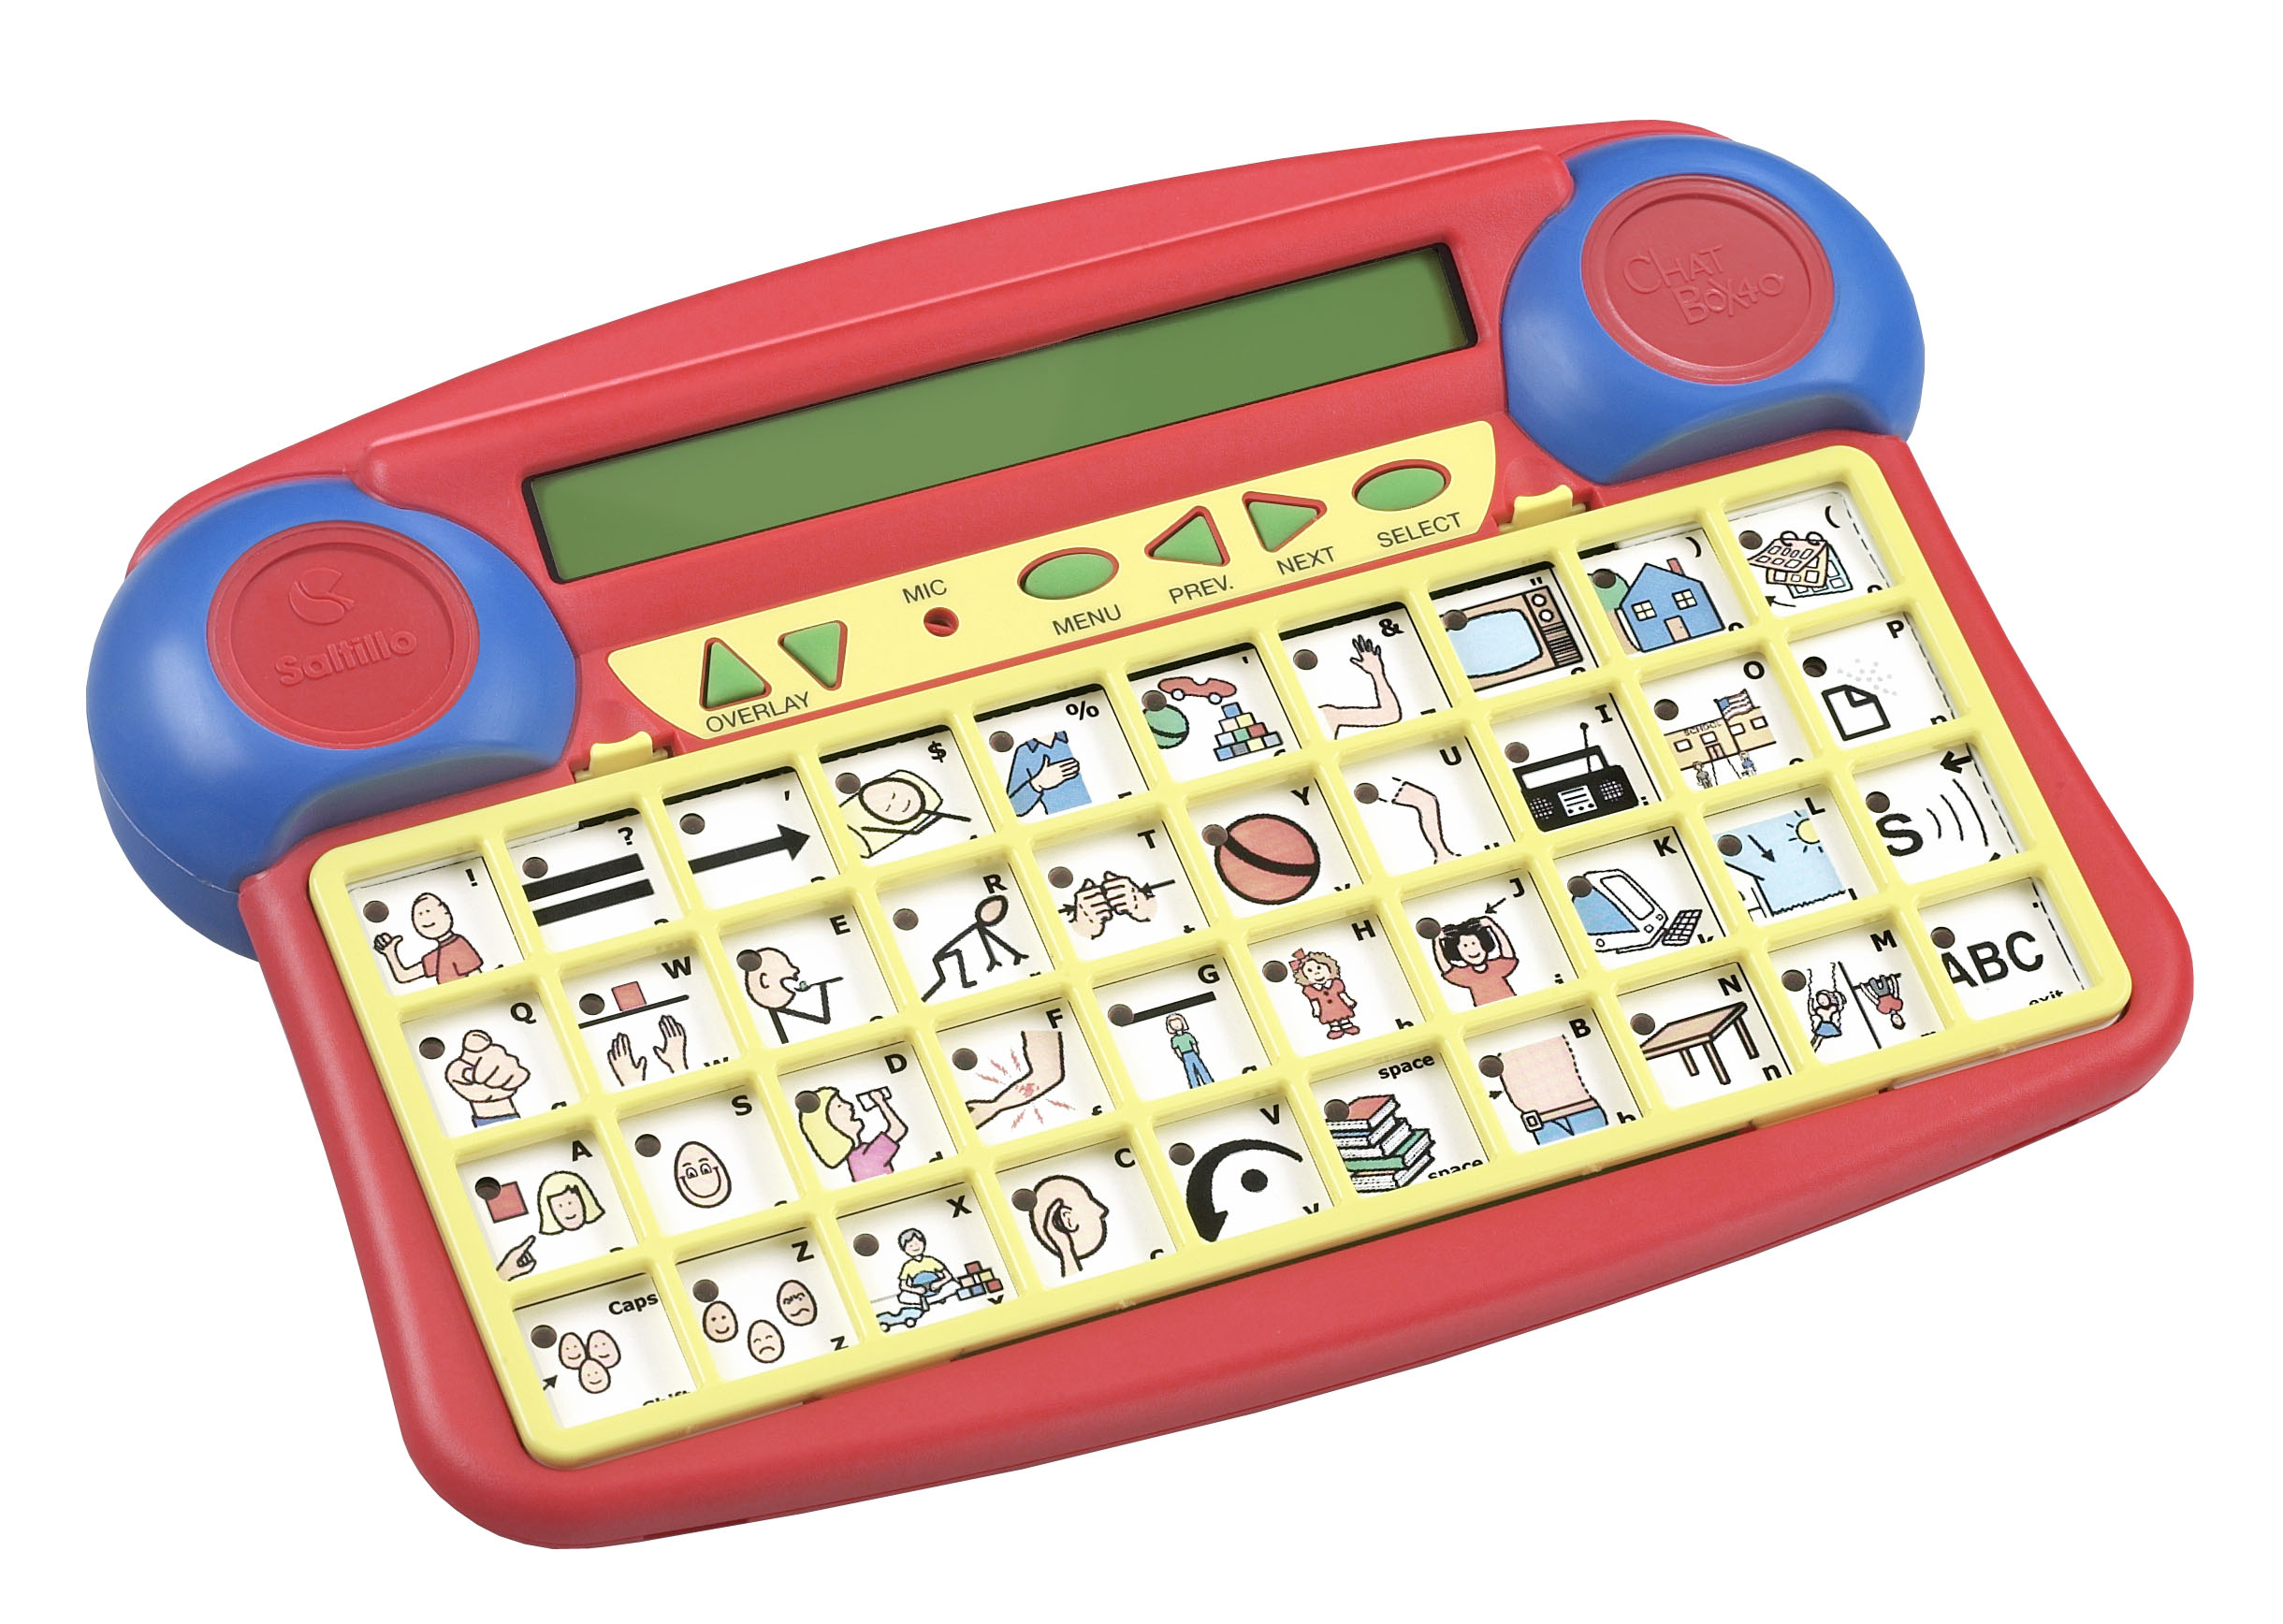
(digitized speech only)

Saltillo Corporation
2143 TR 112
Millersburg, OH 44654 USA
Phone: 1-800-382-8622
Fax: 330-674-6726
Email: aac@saltillo.com or service@saltillo.com
Web Site: www.saltillo.com

Liability Disclaimer
Saltillo Corporation assumes no responsibility for any damage or loss resulting from the use of this manual.
Saltillo Corporation assumes no responsibility for any loss or claims by third parties which may arise through the use of this product.
Saltillo Corporation assumes no responsibility for any damage or loss caused by the deletion of data as a result of malfunction repairs or battery replacement.
The contents of this manual are subject to change without notice.

Copyright Information
ChatBox is a trademark of Saltillo Corporation
The Picture Communication Symbols ™ ©1981–2004 by Mayer-Johnson LLC. All Rights Reserved Worldwide. Used with permission.
Overlays made with Boardmaker ™. Boardmaker ™ is a trademark of Mayer-Johnson LLC. (www.mayer-johnson.com)

Thanks to
Micheline (Rusti) Nichols, CCC-SLP, ATP for the development of the default vocabulary.



Electronic Interference Information
This equipment has been tested and found to comply with the limits for a Class B digital device, pursuant to Part 15 of the FCC Rules. These limits are designed to provide reasonable protection against harmful interference in a residential installation. This equipment generates, uses and can radiate radio frequency energy and, if not installed and used in accordance with the instructions, may cause harmful interference to radio communications.
However, there is no guarantee that interference will not occur in a particular installation. You can determine whether this product is causing interference in your radio or television by turning this product off. If the interference stops, it was probably caused by this product or one of its accessories. You can attempt to correct the interference by using one or more of the following measures:
•Turn the television or radio antenna until the interference stops.
• Move this product to one side or the other of the television or radio.
• Move this product farther away form the television or radio.
• Plug this product into an outlet that is on a different circuit from the television or radio; that is, this product should be controlled by different circuit breakers/fuses from the television or radio.
• If necessary, contact a Saltillo Corporation service technician for assistance.
Changes or modifications to this product which are not authorized by Saltillo Corporation could exceed FCC limits and negate your authority to use this product.
Cet appareil numérique de la classe B respecte toutes les exigences du Règlement sur le matériel brouiller du Canada. This Class B digital apparatus meets all requirements of the Canadian Interference-Causing Equipment Regulations.

CE Environmental Information:
Use: 0° - 45° C; Storage: (-20°) - 50° C; 95% maximum relative humidity @ ambient temperatures less than 40°

Attention! Consult accompanying documents prior to use.

Not intended to be an emergency call device or a sole communication device.

When operated in a medical environment, do not use with any product that is not medically approved.

Version 1.03 9/04
Table of Contents

Welcome to the ChatBox 40 4
The Front of the ChatBox 40 5
The Top of the ChatBox 40 6
Turning ChatBox 40 On and Off 7
Charging the Batteries 9
Exploring the Sample Vocabulary 9
Spelling Keyboard 10
Creating Overlays 12
Exploring Menus 13
Selecting a Different Keyboard Layout 14
Selecting a Different Overlay 15
Recording message 16
Erasing 17
A single key 17
An overlay 17
The entire device contents 17
User Feedback Options Menu 18
Text Messages 18
Backlight 18
Overlay Name 18
Activation Beep 18
Spoken Messages 18
Lock Controls 18
Software Version # 18
Selection Technique Menu 19
10 or 40 Location Keyboard 19
Single Switch, Dual Switch or Joystick Scanning 19
Scanning Speed 22
Latched Scanning 22
Linear/Row Column Scanning 23
Selection Delay 23
Scan Restart 23
Acceptance Time 24
Program Function 25
Care and Maintenance 26
Cleaning 26
Disinfecting 26
Changing Batteries 26
Troubleshooting 27
Technical Support 28
Technical Specifications 30
Warranty & Repairs 31
ChatBox 40 Accessories 32
Welcome to the ChatBox 40®

Welcome to the ChatBox 40, a message system from Saltillo Corporation. ChatBox 40 and ChatBox 40-XT are the newest additions to the cost-effective ChatBox family of voice output devices. They enable individuals who cannot speak to communicate with their friends, families, and others in their lives. These attractive and durable products
offer a combination of features that allow individuals to grow in their communication
capabilities with an affordable device.

The ChatBox 40 allows digitized (recorded) messages to be spoken by pressing buttons on the keyboard. It also supports numerous switch-scanning options for individuals who are unable to press buttons. The keyboard can support 10 large keys or 40 standard-sized
keys. There are 10 levels of messages available with the ability to move from level to level with up and down arrows. A 2-line, LCD display supports text display of the digitized messages and menu-driven setup utilities.

The ChatBox 40 is an easy-to-use device that allows a therapist, teacher, parent, etc. to quickly and easily program new messages for a non-speaking individual’s changing needs.

The ChatBox 40 includes lights to help guide the communicator to the stored messages. The lights will be lit in each key where a message is stored. Other benefits that the ChatBox brings to the beginning communicator are a durable and lightweight design, high quality speech, and portability.

Note: ChatBox 40 should be used as part of an overall set of communication options. It should not be used as a person’s sole source of communication. Neither should it be used as an emergency call device.
The Front of the ChatBox 40:
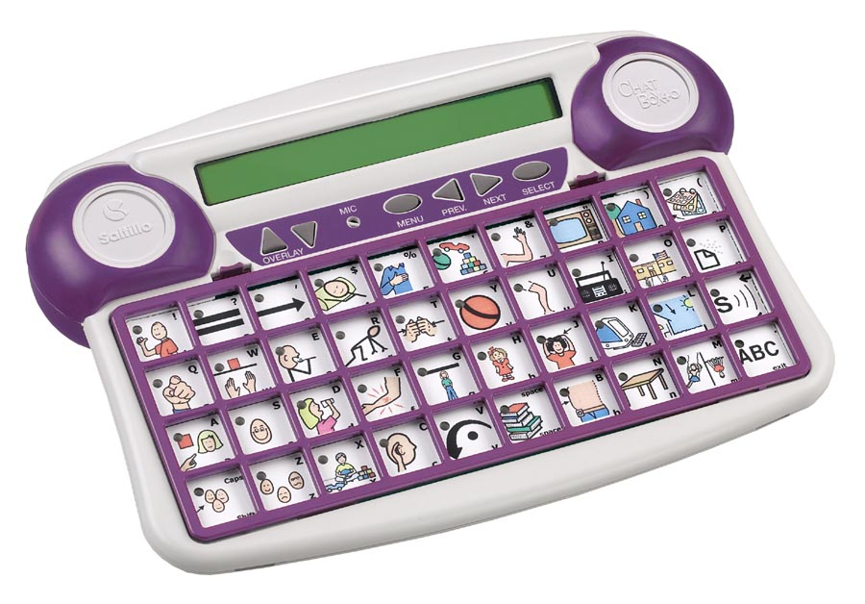

Control Panel MIC Keyboard Keyguard

Control Panel Area – this area contains the control buttons for setting up and modifying the ChatBox 40

Microphone – the recording microphone is under the small round grill near the center of the Control Area, used for recording messages

Keyboard – the ChatBox 40 comes with a 10 and 40 location keyboard. The keys are activated by pressing on them, by using a single or dual switch, or by using a joystick.

Keyguard – the keyguard fits over the keyboard and outlines the keys on the keyboard. To remove the keyguard, squeeze the two tabs toward the keyguard and lift.

Overlay – the paper overlay sits on top of the keyboard and under the keyguard. To change the overlay, lift up the keyguard, remove the overlay protector and replace the overlay with a new one.

Overlay Protector – the overlay protector is a thin piece of vinyl that fits on the top of the overlay and helps to protect it. The ChatBox 40 was shipped with a clear overlay protector and one with the alphabet printed on it for those that benefit from the alphabet and for programming.
The Top of ChatBox 40:

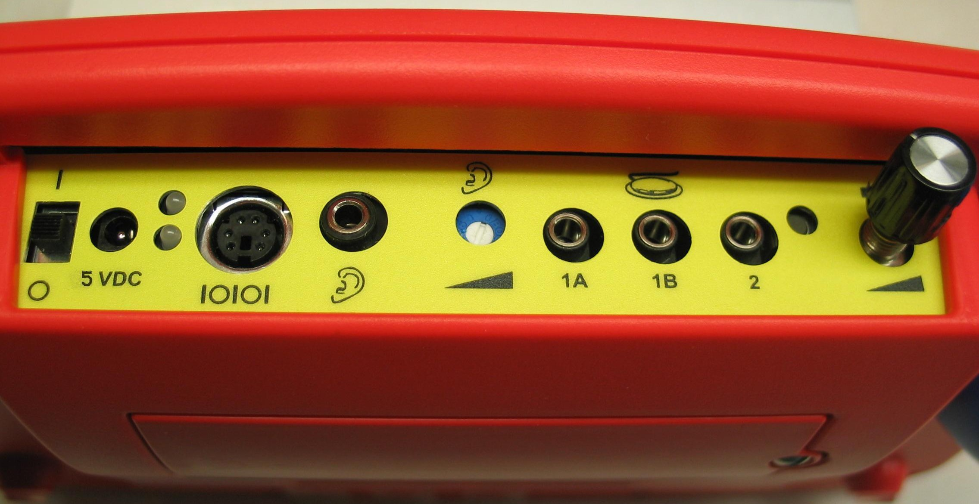

Power Switch, I/O – the power switch allows the device to be turned On (l) or Off (O)

Battery Charging Jack and Lights, 5 VDC – the battery charger that came with the ChatBox 40 gets plugged in here. When it is plugged in, the top light will be red. Once the device is fully charged the bottom light will turn on and be green.

Serial Jack, lOlOl– not implemented in ChatBox 40 at this time

Earphone Jack – not implemented in ChatBox 40 at this time

Volume Control for Earphone – not implemented in ChatBox 40 at this time

Switch Jacks, 1A, 1B, 2 – three switch jacks are available. If you are using one single switch, plug it into 1A. If you are using two single switches, plug one switch in to 1A and one into 1B. If you are using a dual switch, plug it into 2. If using a Joystick, the Up and Down switches need to be plugged into jack 2 and the Left and Right switches need to be plugged into jack 1B.

Reset Button – used only for troubleshooting

Speaker Volume Control – controls the volume of the speaker.

Turning ChatBox 40 On and Off

Your ChatBox 40 can be turned on and off with the ON/OFF (I/0) switch located on the top panel of the ChatBox 40. The top panel is the side facing away from the person using the ChatBox 40. Slide the ON/OFF switch to the I (ON) position when you want to use the ChatBox 40. When you are done using it slide the ON/OFF switch to the 0 (OFF) position.

POWER
SWITCH RESET

ChatBox 40 has been designed with a special battery-saving feature that protects the batteries from discharging if you forget to turn it off. If you leave ChatBox 40 on without pressing any buttons for about five minutes, it will go into a power-down mode where all lights on the unit go out. All you have to do to turn it back on is to press any button on the device. An individual who needs to be able to independently turn ChatBox 40 on but cannot use the ON/OFF slide switch can use this feature. When this individual is done using ChatBox 40 he/she can simply quit using the device. After about five minutes it automatically powers down. When the individual wants to start using ChatBox 40 again, he/she simply presses any keyboard button on ChatBox 40 (this does not include the control area buttons).

Note: If you slide the switch into the ON position and the unit does not turn on, your batteries may be low. Plug a charger into ChatBox 40. If sliding the switch to the ON position does not turn the system on after 5 minutes with the charger plugged in, take a pencil (or similar object) and press the switch inside the small hole labeled ‘Reset’ in the illustration above.
Charging the Batteries

Your ChatBox 40 is powered by rechargeable batteries. Taking care of your batteries can mean that you can use your ChatBox 40 longer between charges. Good battery care can also extend the life of your batteries before they need to be replaced.

How to charge the batteries
Plug the battery charger (provided with the ChatBox 40) into the connector labeled 5V DC on the top panel of the ChatBox 40. Plug the other end of the battery charger into a standard wall outlet.

When to charge the batteries
For most applications, ChatBox 40 batteries should last throughout a typical day. If you have used the ChatBox 40 for more than four hours, feel free to charge the batteries. If the ChatBox 40 is used for shorter amounts of time, you can wait a few days before charging. Also, charge the batteries when you get no response from the ChatBox 40, or when you turn it on or press a key, it beeps 5 times and says:

“Battery is very LOW,
Please plug charger in now.”

The message stays there for 15 seconds and then the unit turns off.

How long to charge the batteries
An eight-hour charge will completely recharge the ChatBox 40 batteries. The ChatBox 40 has a special circuit to protect against overcharging when plugged in for extended periods of time (such as over a weekend).

Which charger to use
Only charge the ChatBox 40 batteries with the charger that you received with the ChatBox 40. In the United States, the battery charger for ChatBox 40 is labeled: Model BC-4. In other countries, check with your local distributor if you have questions as to which charger should be used.

Letting the ChatBox 40 sit for an extended period of time
If for some reason the ChatBox 40 must sit for a period of time (i.e. summer break) without being used the following instructions should be followed:
- Fully charge the device
- Turn the Power switch Off
- Let the device sit without the charger attached

Upon return:
- Charge the device
- Turn the ChatBox 40 On

Exploring the Sample Vocabulary

The ChatBox 40 has three pre-printed overlays included with the machine. Text messages have been put into the machine in Overlay’s 8, 9 and 10 that match the pre-printed overlays. No recordings have been made for the sample vocabulary. If one of these overlays would work recorded messages would need to be added to the text already in place on each key by following the instructions on page 15.

#1 - 10 location demo overlay, matches demo vocabulary in overlay #8
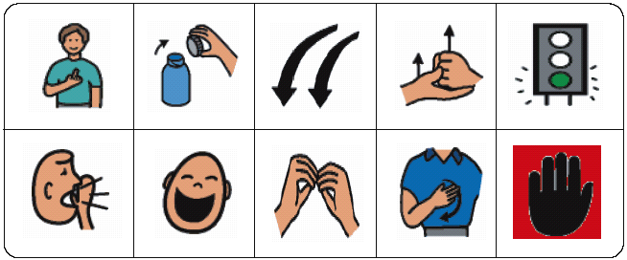#2 - 40 location overlay demo overlay, matches demo vocabulary in overlay #9 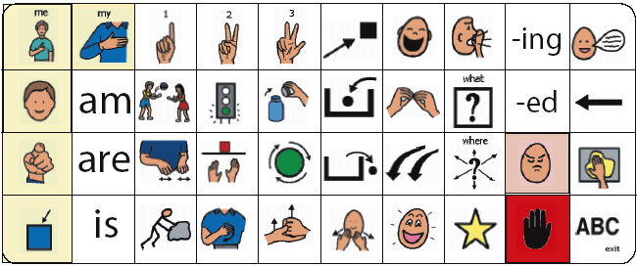
#3 - 40 location overlay demo overlay, matches demo vocabulary in overlay #10 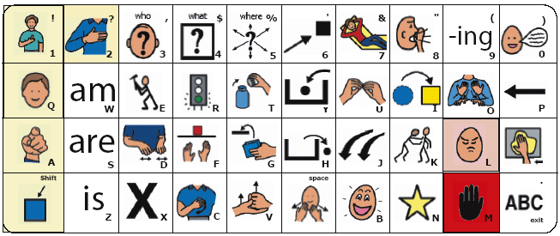

These vocabularies are based on Dr. Stanley Greenspan’s Circle of Communication for the development of interactive communication. The 10-location overlay could be used by, but not exclusive to, a very young child, the first 40-location overlay could be used by, but not exclusive to, the child functioning between 2-5 years of age, and the second 40-location overlay could be used by, but not exclusive to, an adult in a sheltered workshop.

The device was shipped from the factory with the #3 overlay in place on the machine and set to overlay #10 which has the matching text messages. Pushing on the keys should produce a text message on the display that matches the picture on the overlay. The last column contains some tools. Pressing the bottom key in the last column will put the device into a Spelling mode. Note the matching alphabet characters printed in the corner of each key of the overlay. This will give the device user spelling capabilities for generating text messages. To exit spelling mode the bottom right corner key needs to be selected. With the ChatBox 40 the text messages will not be spoken.

To preview the second 40 location overlay (#2) and text messages, choose the down arrow next to Overlay twice and it will move to Overlay 9. Place the other 40-location overlay under the keyguard. Pushing on each key should display matching vocabulary for the overlay.

To preview the 10 location (#1) sample choose the down arrow next to Overlay twice and it will move to Overlay 8. Replace the 40-location keyboard, overlay and keyguard with the 10-location and change the Menu setting to 10 location. See page 14 for details.

Spelling Keyboard

The ChatBox 40 has a 2-line, LCD display that supports displayed text with recorded messages. Showing text with recorded messages is an option that can be turned On or Off in the User Feedback Options Menu. Because showing text is an option, an alphabet keyboard is available for programming the text associated with each recording. The alphabet has been pre-arranged and the layout cannot be modified.

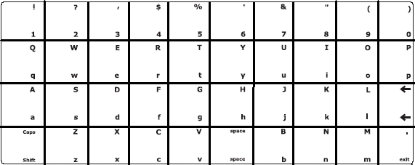

- The alphabet characters, numbers and characters have been arranged in a typical QWERTY keyboard layout.
- The Shift/Caps key is in the lower left corner, selecting this key once will capitalize the next character only, selecting the key twice in a row will shift all characters after that until the Shift/Caps key is selected again.
- Only one key is used for a Space. This key adds a space when selected.
- When shifted the lower right corner key adds a Period (.) to the text. If the keyboard is in spelling mode, choosing the lower right corner key will Exit the spelling mode.
- The third key in the last column provides a Backspace character. This allows for making corrections to text.

While programming the ChatBox 40, whenever asked for text, this keyboard layout will be used. A clear overlay with this text layout was provided with the ChatBox 40. This overlay can be laid on top of the user’s paper overlay as a guide for spelling text.

A “Spelling Mode” function can be added to the user’s overlay. This function will change the speaking mode to spelling mode and will allow the device user to spell text instead of speaking the recorded messages that are at the same keys. When the device user is finished spelling the “Exit” key (lower right corner) can be selected and the recorded messages will now be spoken.

Note: The ChatBox 40 does not have a text to speech synthesizer, which means that even though the device user can spell text the machine has no way of speaking that text. Only recorded messages can be spoken in the ChatBox 40.
Creating Overlays

Three pre-printed demo overlays, 10 blank 10-location overlays, and 10 blank 40-location overlays were included with the ChatBox 40.

Before you begin storing decide what vocabulary you want stored. Vocabulary can be stored as single words, phrases or complete sentences. The ChatBox 40 provides an option for text to be displayed as the recorded message is being spoken. Ten different overlays are possible and they can each be in either a 10 or 40 key layout.

Decisions that need to be made prior to starting your storing process:
- What size keyboard layout does this person need i.e. 10 or 40 keys?
- Will displayed text along with the recorded messages be of benefit?
- Will the vocabulary be organized with single words that can be combined to form messages, form phrases, form complete sentences, or a combination of all of the above?
- Will all vocabulary be stored on one overlay or will it be spread over multiple overlays?
- If multiple overlays, what vocabulary belongs on each overlay?
- What functions, if any, need to be included on each overlay and where will they be?

Once these questions have been answered then you need to consider how the vocabulary on each key will be represented on the overlay itself. Digital pictures can be attached to the overlays, photos cut from many sources can be attached, pictures can also be drawn on the overlays.

The BoardMaker program from Mayer Johnson Inc. can be used to print overlays from a computer. The template for the ChatBox 40 is available from the Mayer Johnson web site at www.mayer-johnson.com, choose downloads, boardmaker files, pre-made grids and choose ChatBox 40 from the device listing.

Programming Note: If text being displayed while the recorded message is being spoken is of value then the alphabet must be available to the programmer. A clear overlay with the pre-printed alphabet layout was provided with the ChatBox 40. Prior to programming any text, be sure to have the clear alphabet sheet on the machine.

Note: Saltillo offers overlays that were created specifically for printers. They come in a set of 10 for 10-location and 10 for 40-location on 8.5” x 11” sheets that are compatible with Boardmaker. These overlays have the holes pre-punched for the icon prediction lights and are perforated around the outside edge for proper fitting into the keyboard. Call Saltillo for ordering information or visit our web site at www.saltillo.com to order on-line.
Exploring Menus

The menus contain settings for customizing the ChatBox 40 to accommodate the needs of each individual using the device.

Selecting the “MENU” button from the front control panel accesses all menus.

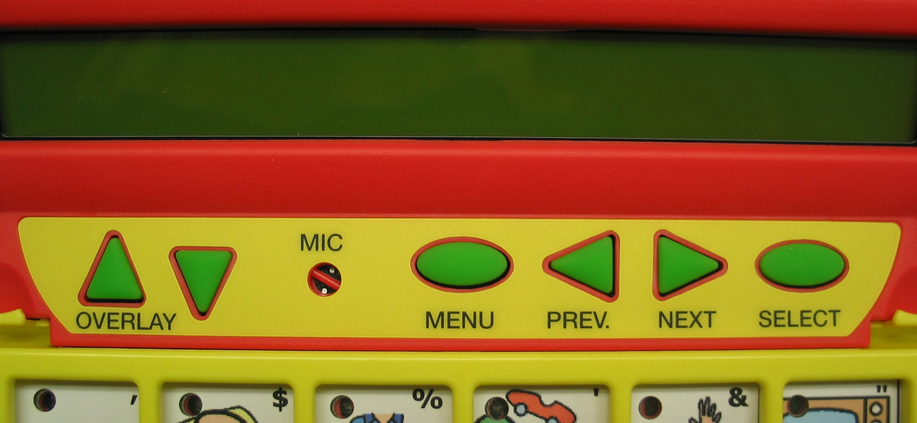

The “Prev and Next Arrow” buttons are used to step through the different menus:
- Record Message – allows recorded messages to be stored to a key
- Erase – allows a chosen key to be cleared
- User Feedback Options – contains options that effect the feedback from the device
- Selection Technique Options – contains options that effect the selection of the keys
- Program Function – allows functions to be stored to keys on the overlay

Choose the “SELECT” button to open the specific menu. Once open, selecting the “Prev & Next Arrow” buttons are used to step through the menu options.

Choosing “MENU” again will close the menu.

At times, when in the menus, you have an option to spell some text. With ChatBox 40 you were provided a clear overlay with the alphabet printed in black. This overlay is intended to sit on top of the user’s overlay for spelling text while programming the system. This alphabet arrangement is set and cannot be modified.

Further explanation of each menu follows.
Selecting a Different Keyboard Layout

The ChatBox 40 allows for a 10 or 40 location keyboard layout. The system was provided with a 10 & 40 location keyboard, paper overlays and keyguards.

In order to change the keyboard layout both the physical keyboard and the internal settings must be changed.
Physical Keyboard:
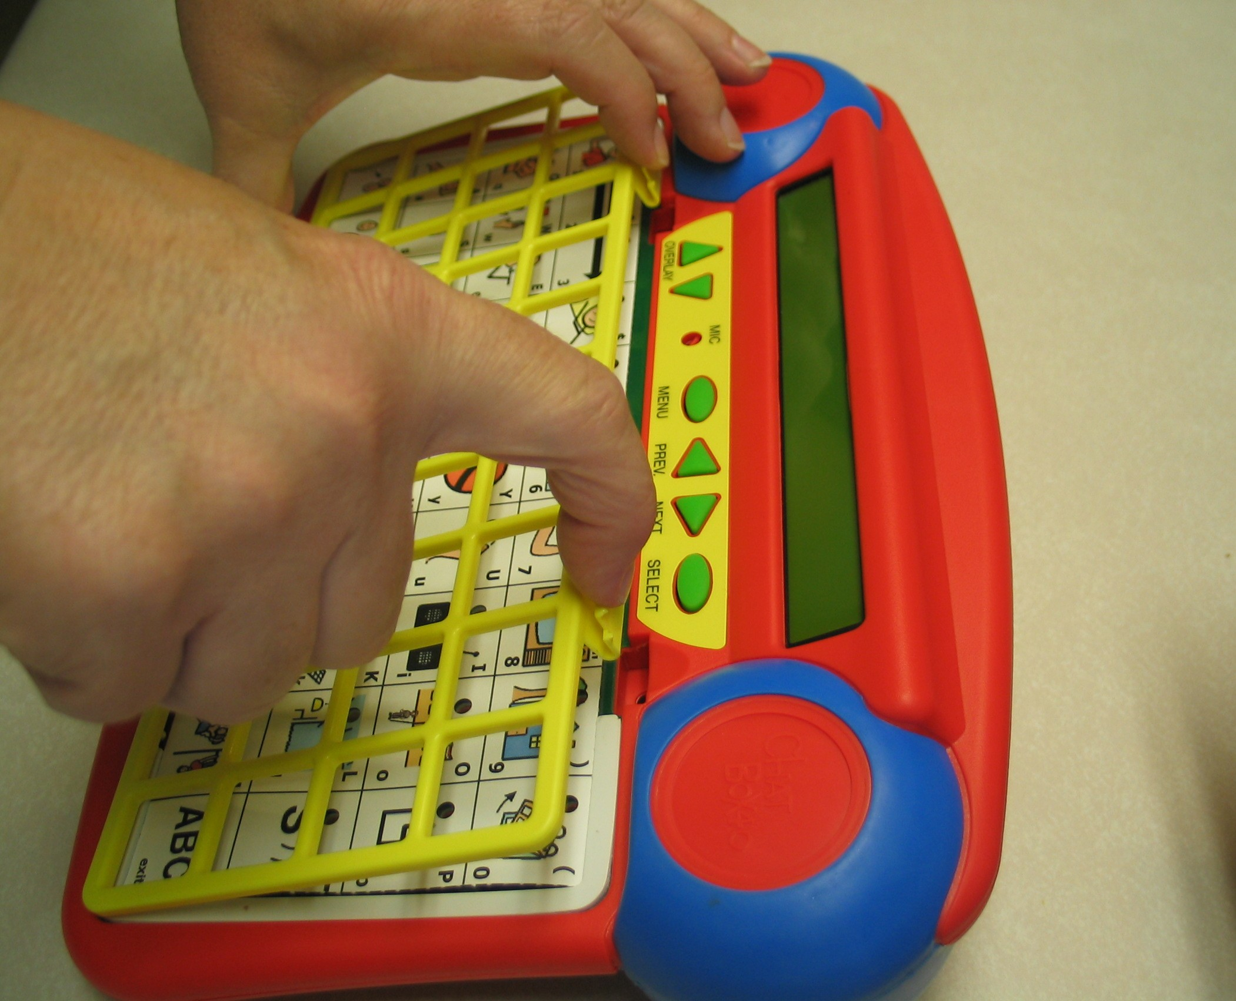
-remove the keyguard by squeezing the two latches at the top of the keyguard and lifting
-remove the overlay and overlay protector
-lift up on the green keyboard and set to the side
-replace the keyboard with appropriate size (making sure the holes for the lights are in the upper left corners of each key)
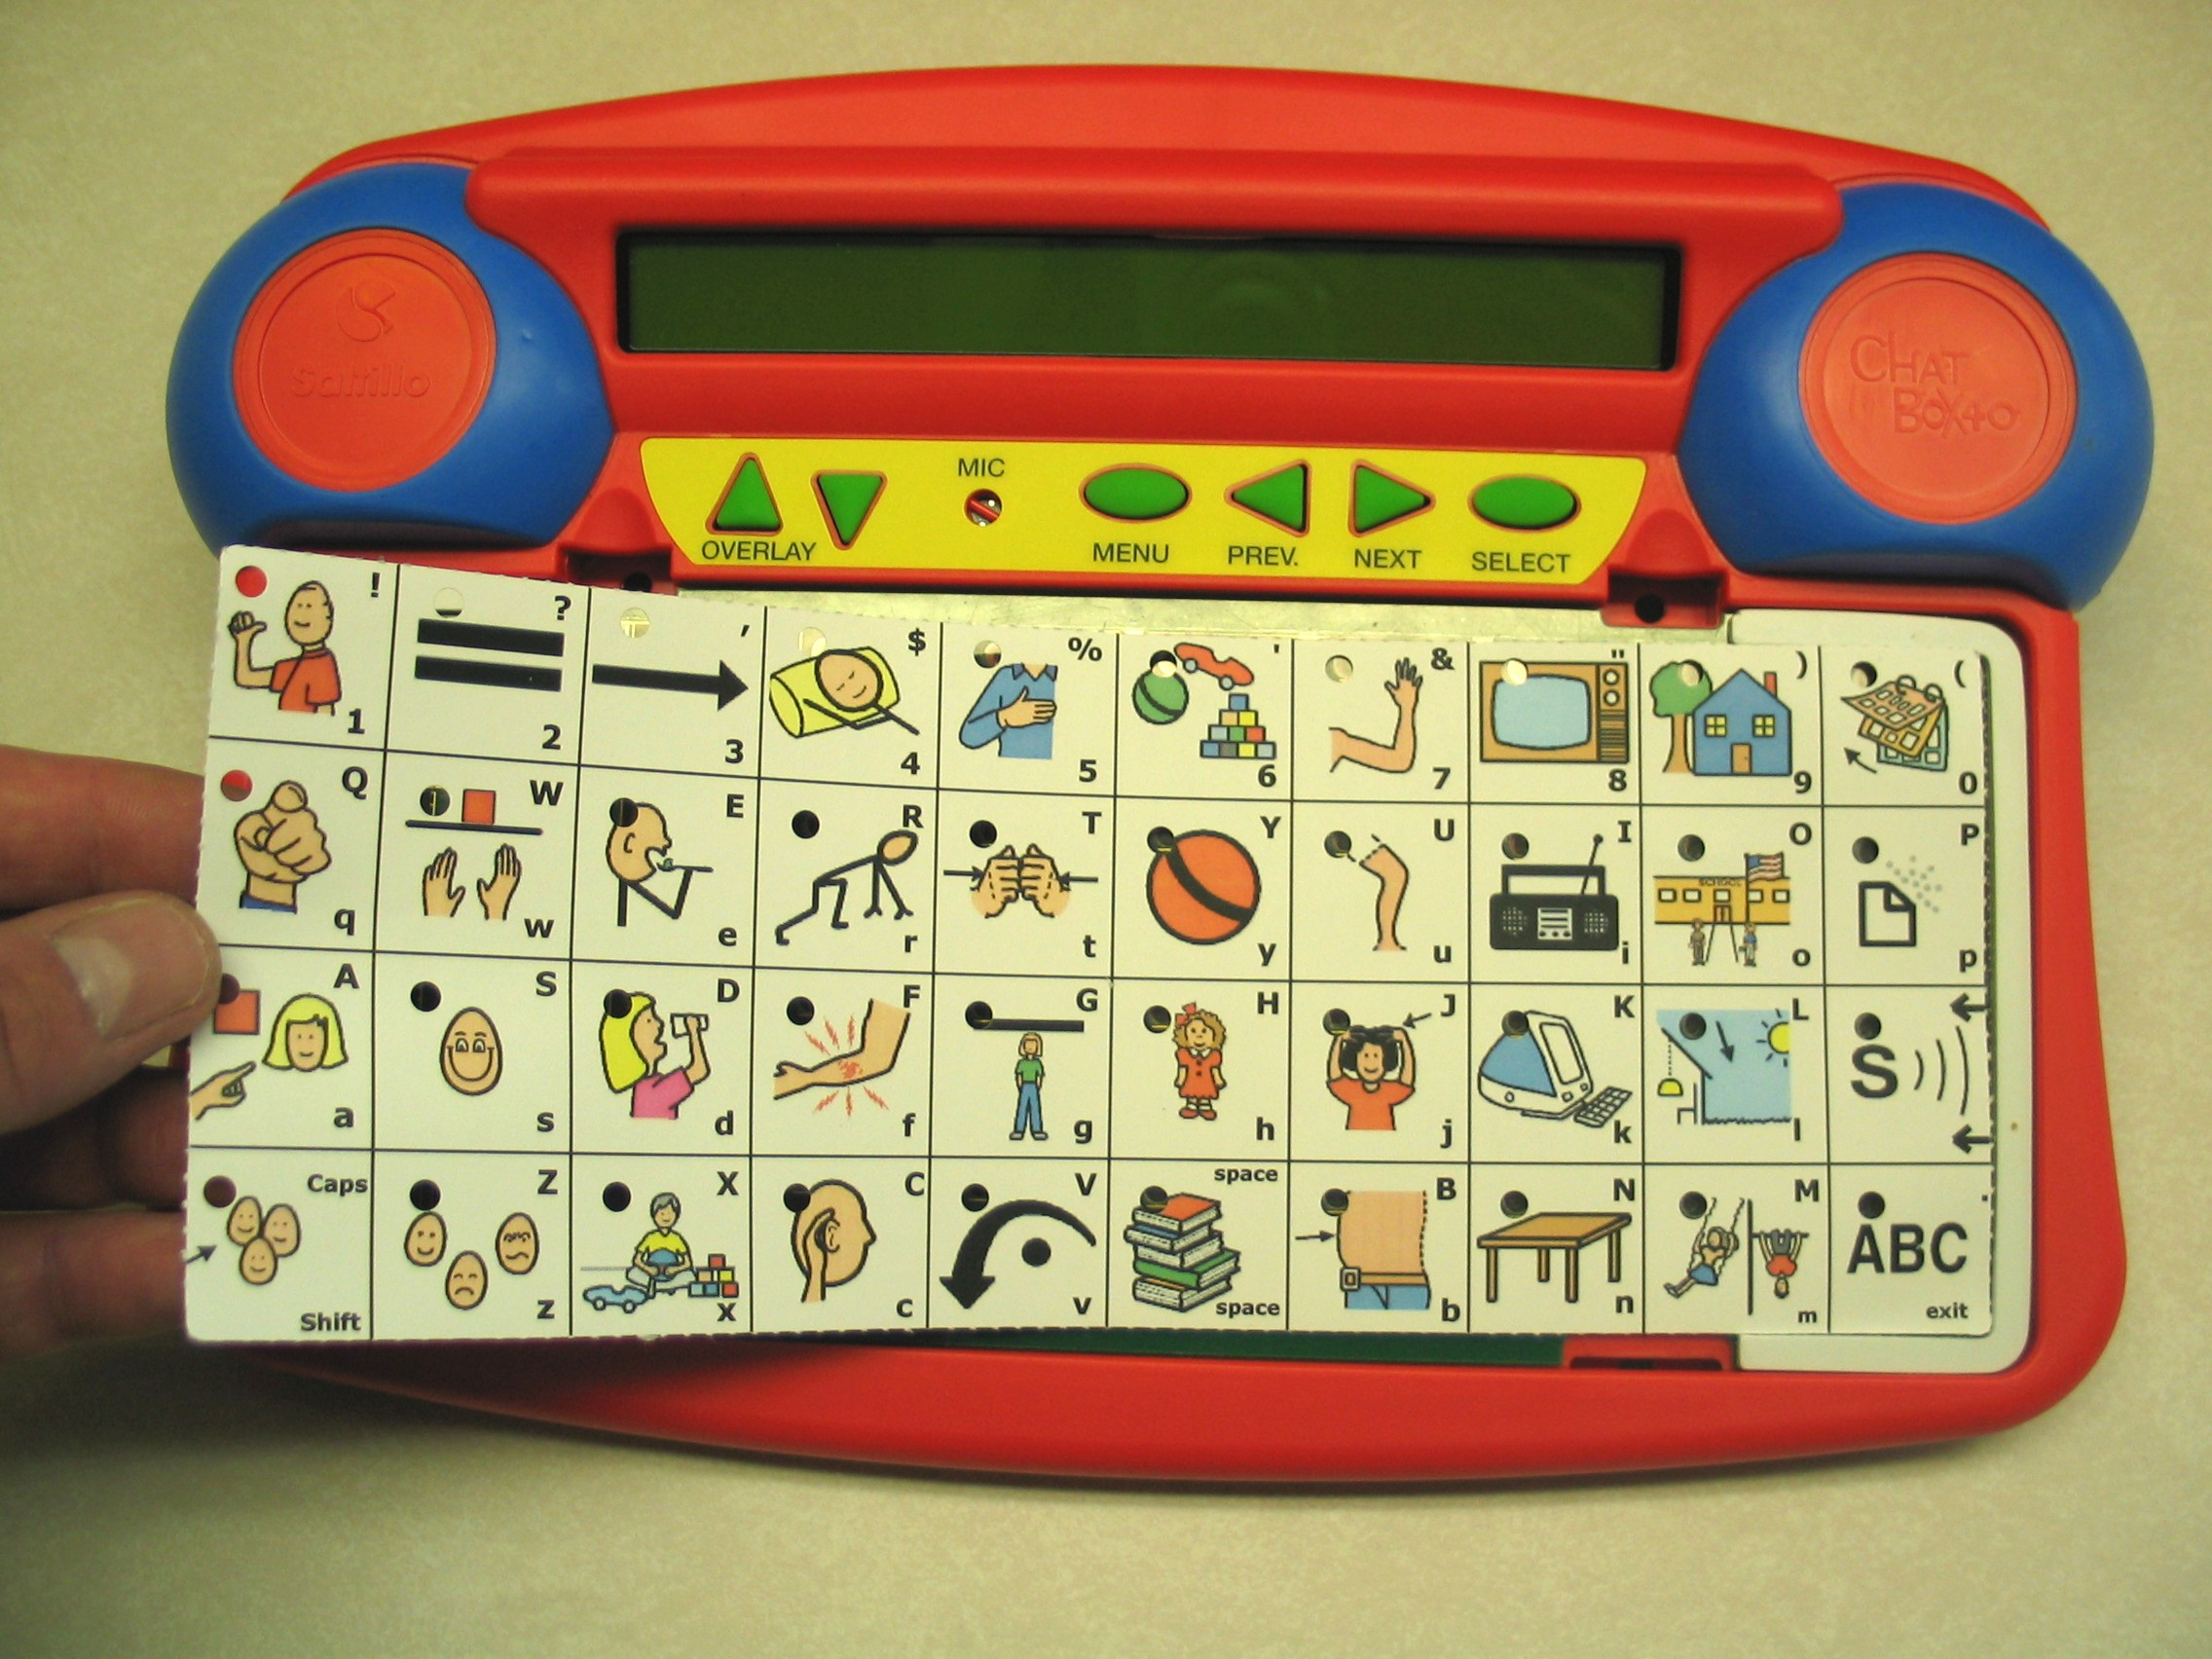
-new overlays and the overlay protector can be set within the frame of the keyboard (again, make sure the holes for the lights are in the upper left corner)
-replace the keyguard with the new size by sliding the tabs at the bottom into the openings in the case, laying the keyguard down flat and letting the latches click into place

Internal Settings:
-choose MENU from the Control Panel Area
-tap the NEXT button until you see Selection Technique Options
-choose SELECT
-choose SELECT again
-tap NEXT to change the number of keys
-choose MENU to close the menu
Selecting a Different Overlay

ChatBox 40 has 10 different overlay memory areas, which may be used for different activities, different classes, or even different students.

There are two aspects of switching to a different overlay. First, you may want to change the paper overlay. You can change the overlay by squeezing the tabs at the top of the keyguard and lifting up. Simply lift the overlay up and put a different overlay in its place. You received several 10-location and several 40-location overlays with your ChatBox 40.

The second aspect to switching overlays is that you must change to a different memory overlay area in ChatBox 40. This means that you can program one overlay memory with the vocabulary that may be needed in one situation (at school, for instance) while a second overlay memory is programmed with the vocabulary that is needed at home (for example).

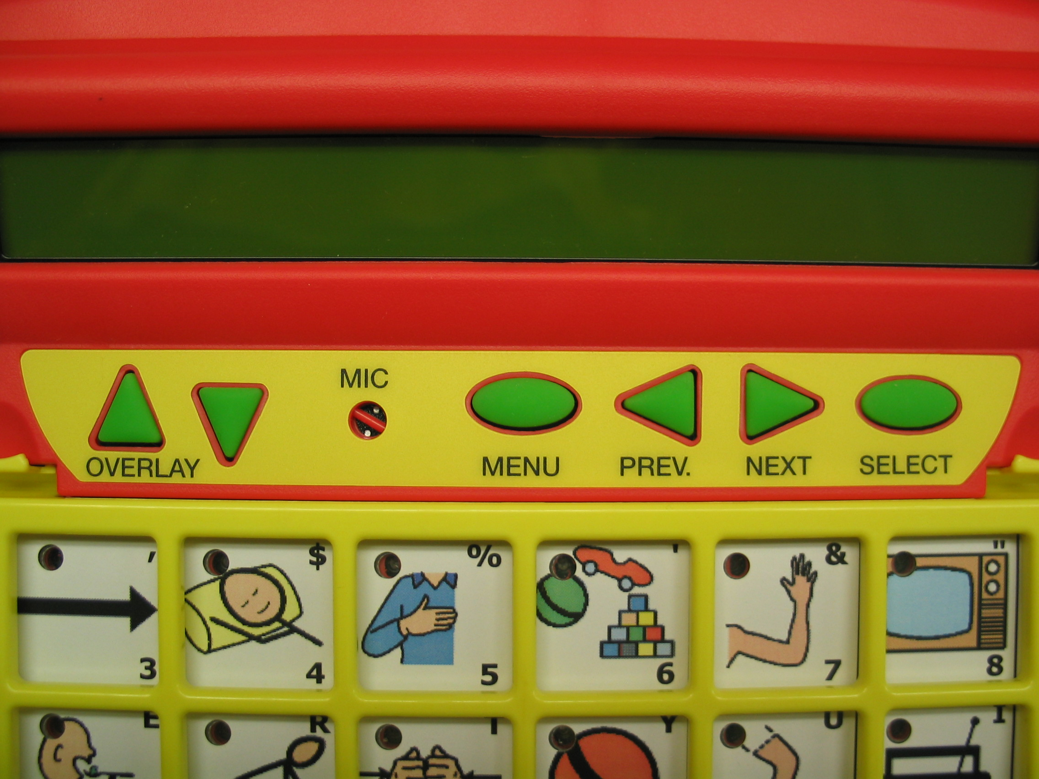

To change to a different memory area, use the arrow buttons labeled Overlay in the Control Panel area. Each time an “Overlay” button in pressed the device advances to the next overlay number to indicate which overlay is selected (1-10).

Recording Messages

Recorded messages in the ChatBox 40 must first be programmed by a person with a natural voice. Recording a message into the ChatBox 40 consists of recording a voice message and selecting the key, which will later be pressed to speak the message. You can record up to 3 minutes of speech into each button.

Note: The ChatBox 40 allows for an optional text message to be displayed as the recording is spoken. This option was turned On at the factory. If you aren’t asked to enter text after recording a message this option must be turned on in the User Feedback Options prior to recording messages if displayed text would be of value. (see User Feedback Options for details)

Prior to recording:
If you plan to include text with your recorded message you must have the clear overlay with the pre-printed alphabet in place on the machine.
To record a message:
- Choose MENU, Record Message is the first option
- Choose SELECT (screen will prompt you through the process)
- Push and hold the key you would like to record a message at while you speak the recording
- Release the key immediately after making your recording to save memory space.
If “Text Messages” is On in the User Feedback Options Menu, then you will be prompted to spell the text you would like to have displayed when the recording is played.
- Either continue recording the remaining keys or choose MENU to exit

Recording messages in different keyboard layouts
Prior to recording messages, determine which keyboard layout is most appropriate. The ChatBox 40 was shipped with both a 10 and 40 location keyboard. Put the keyboard, overlay and keyguard on the ChatBox 40 and you must then go to the Selection Technique menu and set the appropriate layout (see Selecting a Different Keyboard Layout on page14).

Tips
- Record someone’s voice which is age and gender appropriate for the individual using the ChatBox
- Whenever possible, make the recording in a quiet room.
- Keep your mouth about 6 to 10 inches away from the ChatBox 40 and speak in a firm voice at slightly above conversation level.
- Release the key immediately after speaking the message to preserve memory space.
- Experiment speaking at different volumes and at different distances until you find the approach that works best for you.
- If including text with a recording be sure to add a space at the end of the text so the text does not run together on the display.
Erasing

Erasing a key – this process erases an individual key, regardless of what is programmed there
- Choose MENU
- Choose NEXT until Erase is visible
- Choose SELECT (screen will prompt you through the process)
- Push the key you would like to erase
- Choose it again to confirm you want that key erased
- Choose MENU to exit

Erasing a Complete Overlay – this process erases all of the messages and tools programmed in the overlay currently set
- Choose MENU
- Choose the NEXT until Erase is visible
- Choose SELECT
- Choose Down Arrow next to OVERLAY
- Choose SELECT
Press any key except SELECT to exit. Activating Select again will erase entire device contents.

WARNING: the following process erases all of the messages programmed in all 10 overlays of ChatBox 40 and resets all settings to their default setting

Erasing the Entire Contents of the ChatBox 40
- Choose MENU
- Choose the NEXT until Erase is visible
- Choose SELECT
- Choose Down Arrow next to OVERLAY
- Choose SELECT
- Choose SELECT

User Feedback Options

The User Feedback Options Menu contains the following options:

Text Messages = On/Off - determines whether text is displayed with a recorded message or not

Backlight = On/Off – lights the display for night time viewing (using the backlight will reduce battery life)

Overlay Name – allows a name to be assigned to the overlay instead of just a number

Activation Beep = On/Off - determines whether a beep is heard when selecting the keys

Spoken Messages = On/Off – when On, speaks each message as the button is selected, when Off, does not speak until “Speak Compiled Message” is chosen

Lock Controls = Menus only, Menus & Overlay, Unlocked – provides a way to keep curious fingers out of the menus, or out of the menus and from changing overlays

Software Version number – lists the version of ChatBox40 software in the device

To change an option in the User Feedback Options Menu:
- Choose MENU
- Choose NEXT, until you see User Feedback Options
- Choose SELECT
- Choose NEXT, until you see the option you want
- Choose SELECT (the current setting will be displayed)
- Choose NEXT to change the setting. *Overlay Name is the only exception, see below.
- Choose MENU to exit the menu

*after choosing Overlay Name:
- choose NEXT and then you are asked to type the new name you want to give to that overlay. Place the alphabet overlay that came with the device on the keyboard if it isn’t already and type the new name.
- Choose SELECT
- Choose MENU to exit the menu
Selection Technique Options Menu

Selection Technique refers to the method you decide to use to control the ChatBox 40. ChatBox 40 offers direct selection of the keys, single switch scanning, two switch scanning, and joystick scanning. This Menu offers these options and many others to customize the ChatBox 40 for the user’s specific access needs.

Selecting a 10 or 40 Location Keyboard – the ChatBox 40 has the option of using either a 10 or 40 location keyboard. Both the 10 & 40-location keyboard and keyguard were provided with the device. see Selecting a Different Keyboard Layout on page 12

Operating ChatBox 40 with Single switch, Dual switch or Joystick scanning – ChatBox 40 offers single switch scanning, dual switch scanning and joystick scanning options for individuals who cannot press the buttons on the keyboard. Switches are plugged into the top edge of the ChatBox 40 into the slots labeled 1A, 1B and 2.

Depending on the type of switches that you are using will determine where you plug the switch in:
One single switch = 1A

One dual switch = 2
Two single switches = one into 1A and one into 1B
Dual switch w/single switch for manual selection = dual into 2 and single into 1A
Joystick = up and down into 2, left and right into 1B

Personalizing your Selection Technique
All of the options in the Selection Technique Options menu are helpful tools to personalize the ChatBox 40 for your specific needs. Some options are available with certain switch types but not with others. You may want to experiment with different switch types and settings before deciding what works best for you.
- Scan Mode- lets you choose the type of switch you prefer to use. One switch, two switch, or Joystick
- Scan Speed- lets you select how fast or slow you want the keyboard to be scanned. Scanning speed range is from .2 seconds to 10 seconds per step. Available with all switch types.
- Latched Scanning- can be turned on/off. When Off, press and hold the switch to scan. When On, press and release the switch to scan.
Selection Technique Options, continued

Available with all switch types.
- Scan Type- select either linear or Row/column
Can be used with 1 switch or 2 switch scanning
- Scan restart- allows you to restart scanning from the middle of the keyboard, your previous selection, or the upper left corner of the keyboard. Can be used with single switch linear scan, 2 switch linear scan, or a joystick.
- Selection Delay- gives you time to re-activate your switch to deselect an accidental switch activation. Can be used with:
1-switch scanning when latched option is turned On
2 switch scanning when row/column and latched options are selected.
- Acceptance time-helps to avoid unwanted key selections.
Can be used with direct selection and all types of switches.
- Manual Select- available only when the device is set to 2-switch linear scan mode. Requires a dual switch and a single switch to operate.

Using Single Switch Scanning
To use single switch scanning you will need to plug a single switch into the jack labeled 1A on the top of the ChatBox 40. You will need to select either linear or row/column as the scan type from the Selection Technique Options menu (see page 18 for instructions).

When “linear” is the scan type selected the locations are scanned one by one across the rows one row at a time. When the lamp is lit on the key you want press the switch to select it.

When “row/column” is the scan type selected the scan first moves down the rows. Activate the switch when the lamps are lit in the row you want. The scan then proceeds across the selected row. Activate the switch again when the lamp is lit on the key you want to select.

Using 2 Switch Scanning
To use 2 switch scanning you will need to plug two single switches or one dual switch into the top of the ChatBox 40. When using 2 single switches plug one switch into the jack labeled 1A and the other into 1B on the top of the device. If you are using a dual switch it should be plugged into the jack labeled 2 on the top of the device. You will need to select either linear or row/column as the scan type from the Selection Technique Options menu (see page 18 for instructions).

When linear is the scan type selected and you are using 2 single switches you will need to turn the “latched scanning” option off. Press and hold the switch in 1A to scan across the rows. The switch in 1B is used to scan up or down the columns. Press and hold either switch to start the scan. To change the scan direction you will need to release the 1st switch and quickly press the other. When the scan advances to the key you want, simply release the switch and the key will be selected.

Selection Technique Options, continued
When linear is the scan type selected and you are using a dual switch, one side of the switch will act like a single switch plugged into 1A and the other side of the switch will act like a single switch plugged into 1B as described above. Press and hold either side of the switch to start the scan. To change the scan direction you will need to release the 1st side of the switch and quickly press the other. When the scan advances to the key you want, simply release the switch and the key will be selected.

Note: Manual Select is an option available only in 2-switch linear scan mode, and requires a dual switch and a single switch to operate. The dual switch must be plugged into the jack labeled 2 on the top of the ChatBox. The single switch must be plugged into the jack labeled 1A. (If the single switch gets plugged in to 1B the ChatBox will appear to lock up.) One side of the switch controls the scan across the rows the other side controls the up and down scan. Press and hold either side of the switch to start the scan.
Press the other side to change the scan direction. Release the switch to stop the scan on the key you want to select, then press and release the switch plugged into 1A to make the key selection.

When row/column is the scan type selected and you are using 2 single switches, press the switch in 1A to start the scan down the rows. Select the row you want using the switch plugged into 1B. The row will be selected and the scan will proceed across the row. You can then select a key using either switch.
If, after you start the scan with the switch in 1A, you then tap the same switch again to select the row you want, the row will be selected and the scan will stop. 1A then becomes an inactive switch. 1B must be activated to make the scan proceed across the row. You can then select a key with either switch.

When row /column is the scan type selected and you are using a dual switch, one side of the switch will act like a single switch plugged into 1A and the other side of the switch will act like a single switch plugged into 1B as described above. To begin the scan you will need to activate the 1st side of the switch. The scan will start down the rows. Activate the 2nd side of the switch when the lamps in the row you want are lit. The scan then proceeds across the selected row. You can then activate either side of the switch when the lamp is lit on the key you want to select.
If, when you activate the 1st side of the switch to begin the scan, and then tap the same side of the switch to select a row, the row will be selected and the scan will stop. That side of the switch then becomes inactive. You must then activate the other side of the switch to make the scan proceed across the row. You can select a key using either side of the switch.

Choosing the type of switch needed:
Along with plugging a switch in, the ChatBox 40 needs to be set to correspond with the number of switches you are using:
- Choose MENU
- Choose NEXT until you see Selection Technique Options
- Choose SELECT
- Choose NEXT until you see “Scan Mode = Current Setting:…”
Selection Technique Options, continued

Choose SELECT
- Choose NEXT to step through One Switch, Two Switch or Joystick options
- Choose MENU to lock in the option that matches your switches

Note: the keyboard will remain active regardless of the menu setting

Setting the Scanning Speed – scanning speed is the length of time that it takes to scan from one location to the next on your ChatBox 40. The speed ranges from .2 seconds per step to 10 seconds per step. To change the scanning speed:
- Choose MENU
- Choose NEXT until you see Selection Technique Options
- Choose SELECT
- Choose NEXT until you see “Scan Speed – Cur. Setting: .2 – 10 seconds”
- Choose SELECT
- Choose NEXT until you see the speed you want
- Choose MENU to exit

Choosing Latched Scanning On/Off – To scan with Latched scanning Off, the switch needs to be pressed and held. The lights go out and while you are holding the switch you see the scanning lights indicating the scanning location. Once the light is at the message wanted the switch is released to make the activation. Latched scanning being turned On eliminates the need to maintain the switch to keep the scan moving. To scan, press and release the switch and the scanning continues until the switch is pressed again.

Step Scan – turning latched scanning Off provides an option for step scan. Instead of pushing and holding the switch, the switch can be selected and released repeatedly. When you want select a key, pause at that location and the key will be activated. The amount of time you have to press the switch to scan to the next location is the same as the scanning speed.

To turn Latched Scanning On or Off:
- Choose MENU
- Choose NEXT until you see Selection Technique Options
- Choose SELECT
- Choose NEXT until you see “Latched Scanning – Current Setting: On or Off
- Choose SELECT
- Choose NEXT to change the setting
- Choose MENU to exit

Selection Technique Options, continued

Choosing a Scan Type of Linear or Row/Column Scanning – in Linear scan, locations are scanned one by one. The ChatBox 40 also uses a feature called Predictive Scanning. Predictive Scanning means that you only scan to locations that are programmed with messages. When you start to scan, the prediction lamps go out and you start to scan one by one through the keys that had been predicted. See Scan Restart below for details on determining where the scan will re-start after each selection.

In Row/Column scanning, you scan top to bottom through the rows. Once a row has been selected, the scan begins from left to right within the chosen row. Predicted Scanning is used when moving across the rows and only scans to locations that are programmed with messages.

To change the Scan Type:
- Choose MENU
- Choose NEXT until you see Selection Technique Options
- Choose SELECT
- Choose NEXT until you see “Scan Type – Current Setting:Linear or Row/Column
- Choose SELECT
- Choose NEXT to change the setting
- Choose MENU to exit

Selection Delay – a delay can be added after an activation of a key that gives you a chance to change your mind before a key is activated. The amount of delay is automatically set at whatever your scanning speed is. If your scanning speed is set to 1 second, then once you select a key you have 1 second in which to change your mind and “de-select” the key by hitting your switch again. To change the Selection Delay setting:
- Choose MENU
- Choose NEXT until you see Selection Technique Options
- Choose SELECT
- Choose NEXT until you see “Selection Delay – Current Setting: On or Off”
- Choose SELECT
- Choose NEXT to change the setting
- Choose MENU to exit
Note: Selection Delay works with scanning but not with Direct Selection.

Scan Restart – when using Linear Scan type the scan can restart either in the upper left corner, the middle of the keyboard or at the location of the previous selection. To change where the scan restarts:
- Choose MENU
- Choose NEXT until you see Selection Technique Options
- Choose SELECT
- Choose NEXT until you see “Scan Restart – Current Setting: Upper Left Corner, Middle of Keyboard or Previous Selection
Selection Technique Options, continued

- Choose SELECT
- Choose NEXT to change the setting
- Choose MENU to exit
Note: this is not an option in Row/Column Scanning

Acceptance Time – determines the amount of time it takes for the ChatBox 40 to accept a location and activate the key. Adjusting this setting can prevent unwanted key selections if a key or switch is accidentally activated. The acceptance time is the amount of time you must maintain contact with your switch before the key you have selected is accepted. The default acceptance time is .02 Seconds. The delay ranges from .02 seconds to 3 seconds. If the acceptance time is set to 1 second, you must press and hold the key or switch for 1 second to select it. If the key or switch is released before 1 second has passed, no selection is made.

To change the Acceptance Time:
- Choose MENU
- Choose NEXT until you see Selection Technique Options
- Choose SELECT
- Choose NEXT until you see “Acceptance Time – Current Setting: .02 – 3 seconds
- Choose SELECT
- Choose NEXT to change the setting
- Choose MENU to exit
Note: Acceptance Time works with scanning and direct selection
Program Function

Along with recorded messages the ChatBox 40 allows for Functions to be programmed on keys to perform various commands. The functions included are:

Clear Display – clears all text from the display
Delete Last Selection – deletes the last message selected
Speak Compiled Message – Recorded messages can be assembled using multiple keys. The messages can then be spoken as one single message by choosing Speak Compiled Message. Clear Display can be chosen to clear the display and start compiling another message.

Spelling Mode – shifts the machine into spelling mode. The alphabet layout is included with the device on a clear overlay that can be laid over top overlay. To exit the spelling mode the bottom right corner button must be chosen.

Shift – capitalizes the first character of your message. Choosing Shift twice in a row locks capitalization On all of the letters in the selected messages

To Program a Function on a Key:
- Choose MENU
- Choose PREV until you see Program Function
- Choose SELECT
- Press the key where you want to program the function
- Choose NEXT until you see the function you want
- Choose SELECT
- Choose MENU to exit
Care and Maintenance

Your ChatBox40 device is intended for use in normal communication situations. Your device is not waterproof, so use caution when using it around water. As with most electronic devices, you should never use ChatBox 40 when you are actually in the water (for example, a pool or bath).

Cleaning:
The ChatBox 40 can be cleaned by wiping it with a dry or damp (not wet) cloth. Do not get water or soap into the speaker or microphone. The overlay protector can also be cleaned with a damp sponge or a window cleanser. Clean the keyguard in hot, soapy water.

Disinfecting:
To disinfect your equipment, mix ¼ cup vinegar with 1 cup water. Wipe all equipment with a cloth dampened (not wet) in this mixture. Allow the equipment to air dry.

Remember to use only the battery charger that came with your ChatBox 40, BC-4

Changing your ChatBox Battery

There will come a time when your ChatBox will no longer maintain it’s charge as long as you may need it to. When this happens you will need to contact Saltillo at 1-800-382-8622 and order a new battery. When it arrives you should shut the ChatBox Off and turn it over. With a screwdriver, remove the single screw holding the battery door on.
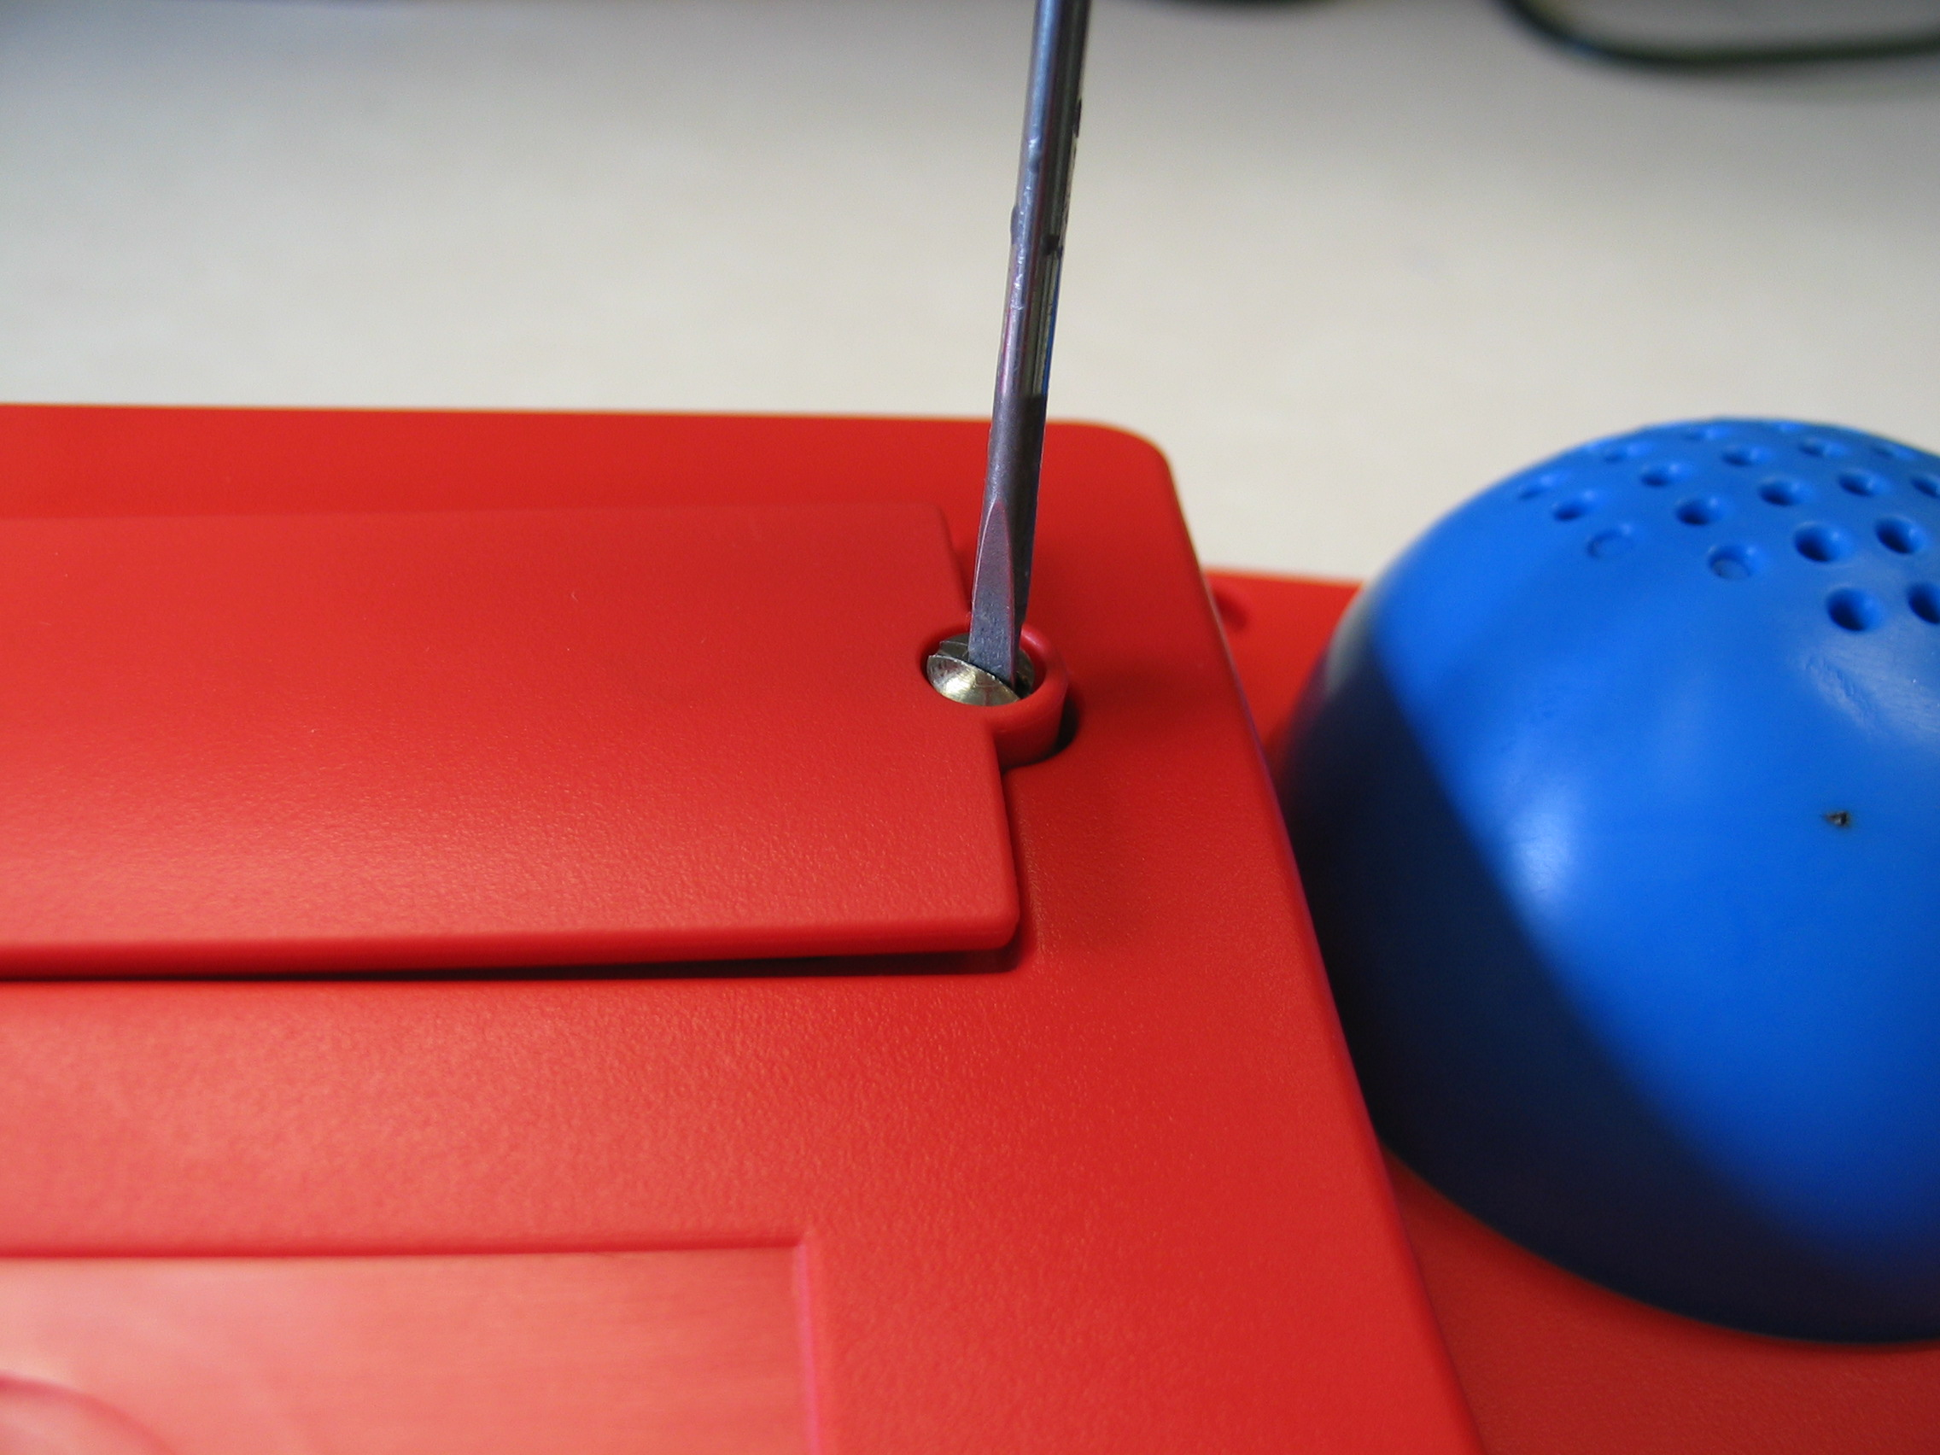
There is a connector to the side of the battery that needs pulled up and the new battery plugged in. Place the wires so they are not pinched when replacing the door.

The Lithium battery pack must be disposed of properly. If your community/state has recycling regulations, the battery pack must be recycled. If you discard all or part of your device, dispose of all electronic components according to local regulations.

Troubleshooting

ChatBox won’t turn On: If you slide the switch into the ON position and the unit does not turn on, your batteries may be low. Plug a charger into ChatBox 40. If sliding the switch to the ON position does not turn the system on after 5 minutes with the charger plugged in, take a pencil (or similar object) and press the switch inside the small hole labeled ‘Reset’ in the illustration above.

ChatBox is On but pressing the keys won’t activate consistently: If you are pressing keys on the face of the machine and they don’t activate consistently you may not have the keyboard sitting tightly enough against the machine. Remove the keyguard, pick up the overlays and the keyboard. Make sure that there isn’t any debris or crumbs keeping the keyboard from sitting flat against the face of the machine. Replace the keyboard making sure that the holes for the lights are in the upper left corners of each key. Replace the overlay and the keyguard. Be sure the keyguard snaps into place securely.

ChatBox is not speaking: There are a number of issues that could keep the ChatBox from speaking.
-Volume is turned down – rotate the volume knob and try speaking again
-Message has been erased – light should be On, if not try entering message again
-Spoken Messages may be turned Off in the User Feedback Options Menu. To turn Spoken Messages on:
- choose MENU
- choose NEXT until you see User Feedback Options
- choose SELECT
- choose NEXT until you see “Spoken Messages Current Settings: On/Off”
- choose SELECT
- choose NEXT
- choose MENU to exit the menu and make sure it speaks

ChatBox is speaking but no text is showing on the screen: There is an option in the ChatBox to turn off the text messages. To turn text messages on:
- Choose MENU (If after choosing MENU you don’t see anything on the screen call Saltillo Technical Support)
- Choose NEXT until you see User Feedback Options
- Choose SELECT, you should see “Text Messages – Current Settings: On or Off”
If they are Off:
- Choose SELECT
- Choose NEXT
- Choose MENU
If they are On:
- Re-record the message and make sure you type text when asked.

While Scanning, Scan doesn’t advance or select properly, or device becomes unresponsive: make sure the switches are plugged in securely to the device.

ChatBox seems to be locked up: Push the Reset button on the top edge of the machine
If you are in 2 switch linear scan and using manual selection, your “select” switch must be plugged into 1A. If it is in 1B the device will appear to Lock Up. RESET

Getting Technical Support
If you run into problems that you can’t solve by any of the above methods, contact technical support by phone at 1-800-382-8622 between 9am and 5pm EST, or by email at service@saltillo.com. We’ll do our best to get things working as quickly as possible.
Technical Specifications

Charger Input:
Regulated 5 VDC @ 1.0 amp, center is positive, 1.7 mm inside diameter, 4mm outside diameter

in USA, use Model Number BC-4

External switch connector:

3.5mm mono jack: SET standard

connect to standard switch closure or dry relay contact

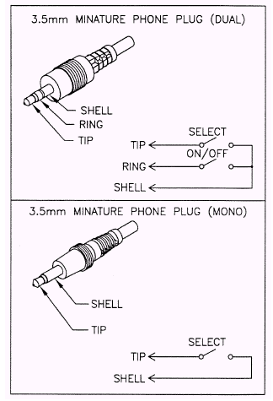

Earphone connector:

3.5mm mono jack

connect 4 to 16 ohm earphone

Joystick connections:
Use two dual 3.5mm plugs, plug one into the jack labeled 2 and one into the jack labeled 1B

Storage Temperature:

-20º C to 70° C

Storage Humidity:
95% maximum relative humidity at ambient temperature less than 40° C

Operating Temperature:
0° C to 50° C

Operating Humidity:
95% maximum relative humidity at ambient temperature less than 40° C

Battery Disposal:
Check with local authorities for regulations on the disposing of Lithium Ion batteries.

Warranty and Repairs

ChatBox 40 is covered under warranty for 1 year after initial purchase. The warranty includes parts, labor and ground shipment back to the customer. The customer is responsible for shipping the ChatBox 40 to the service center. Batteries and physical damage are excluded from the warranty coverage.

Customers living in the United States must call Satlillo Corporation at (800) 382-8622 to obtain a Return Authorization number before returning the ChatBox 40 for repair. Service personnel will attempt to service the unit over the telephone. If this is not possible, you will be issued a Return Authorization number and shipping instructions. Failure to obtain a Return Authorization can result in additional charges.

Customers living in countries other than the United States should contact your distributor for return policies.

ChatBox 40 units that are past their warranty period can also be serviced by Saltillo. Contact Saltillo or your distributor for further details and instructions.
ChatBox 40 Accessories

ChatBox 40 Accessories available from Saltillo include:

Blank Overlays:
Blank ChatBox 40 overlays for further customization and growth. Available in sets of 10.

Computer Printer Overlays:
10 – 8.5” x 11” sheets of paper, each holds a ChatBox overlay. The sheets are designed to work with Mayer Johnson’s popular Boardmaker program. The overlays already include the holes for the scanning lights. They are also perforated so that you can punch them out after printing.

Carrying Case:
An attractive black carrying case comes complete with an adjustable shoulder strap or waist belt to provide a convenient means of carrying your ChatBox.

Carrying Strap:
A black adjustable shoulder strap is available.

